**Foetal Bison Remains and Subsistence Seasonality at the Early Holocene Casper and Horner II Sites, North America**

**Supporting Methods: Guide for Associated R Script**

Ryan P. Breslawski, Tomasin Playford, & Christopher M. Johnston

Email: [rbreslawski@smu.edu](mailto:rbreslawski@smu.edu)

Phone: +1(801)884-9451

Department of Anthropology

Southern Methodist University

PO Box 750 336

Dallas, TX 75275-0235

United States

2019

1. **Getting started ……………………………………………………………… S1**
2. **Entering osteometric information ………………………………………… S5**
3. **Evaluating seasonality hypotheses ……………………………………..…. S8**
4. **Obtaining a SODE from multiple specimens …………………………….. S9**

This R script is based on the program presented in Breslawski and Playford 2017. Two main differences exist between the programs. First, in this script, users are presented with the option to adjust growth curves to account for body size differences between modern *B. b. bison* and Pleistocene *B. b. antiquus*. Next, this script takes metric values for the minimum antero-posterior depth of diaphyses rather than diaphyseal length. It only models growth in the radius, humerus, tibia, and femur (unlike the earlier script, the scapula is not included). The minimum depth metrics are used to estimate diaphyseal lengths for the growth curves. Users are given the option to view length-minimum depth relationship plots for each element.

1. ***Getting started***

Download the script to a directory that you prefer to work from. You will need to install R to run the program (<https://www.r-project.org/>). This script can also be executed in RStudio (<https://www.rstudio.com/>). Users may notice that graphical outputs display slower in RStudio than in the base R GUI. Figures in this guide were generated using the standard R GUI. The program requires seven R packages, all of which are available in the CRAN: *ggplot2*, *gridExtra*, *reshape2*, *quantreg*, *boot*, and *smoother*. Without these packages, the script will experience errors and stop.

To run the program from the R console, use the *source* command from the R or RStudio console: set the working directory to the file location and type source(“PSMFBa.R”)(if the file name has changed, replace the text in quotes as necessary). After pressing [enter], the program will execute and display introductory information. There are three paragraphs of text outlining the program. You can cycle through these by pressing any key.

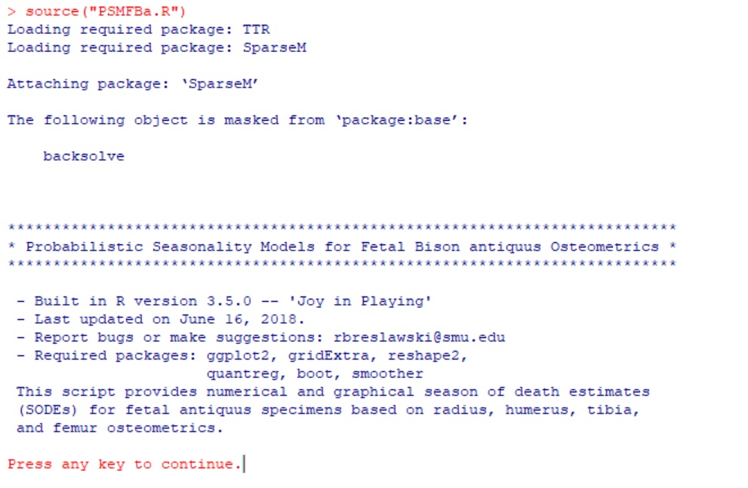

The initial block of introductory text upon sourcing PSMFBa.R.

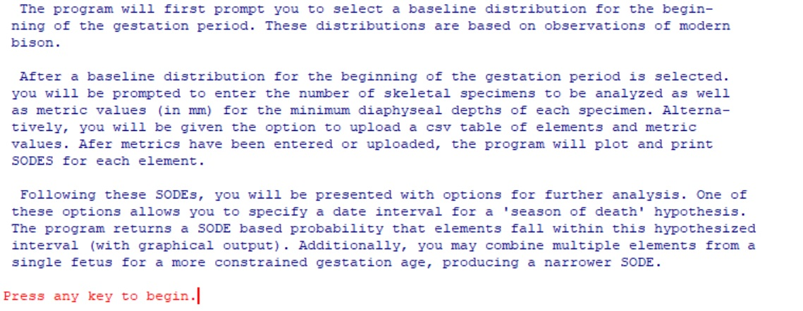

The final three introductory paragraphs.

Following the introductory text, the program will prompt you to select a conception distribution. Fourteen conception distributions are displayed as text with leading index value [i]. The program also plots each conception distribution. You will need to expand the plotting viewer to see these distributions clearly. The plots may take several seconds to load, but they should display within one minute. If using RStudio, do not resize the blank plotting window while waiting for the plots to load, as this will likely produce an error that stops the program. It is safe to resize the plotting window after they have displayed.

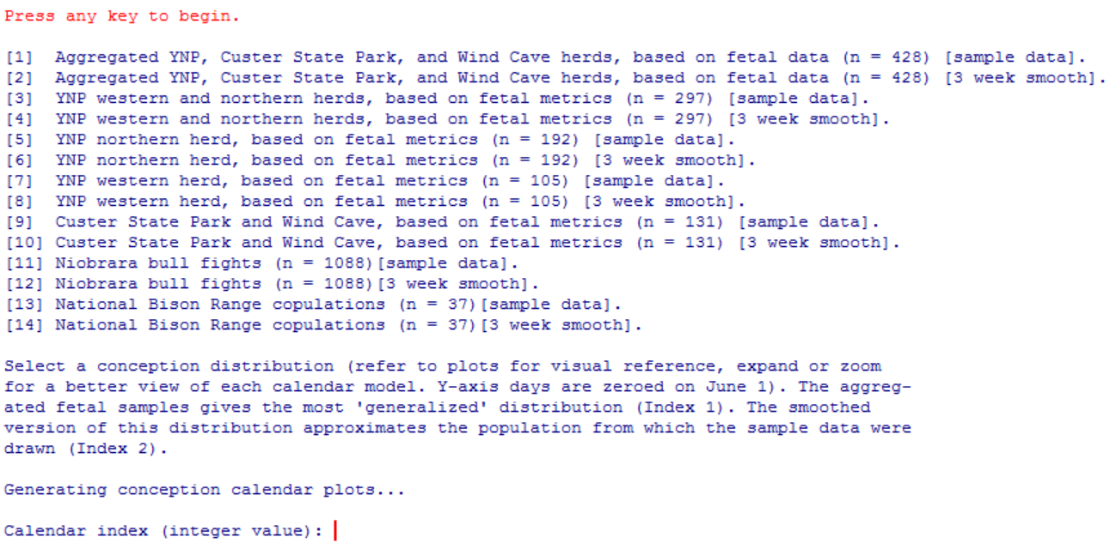

R console displaying conception distributions options. Calendar index (integer value): only displays after the associated plots have loaded.

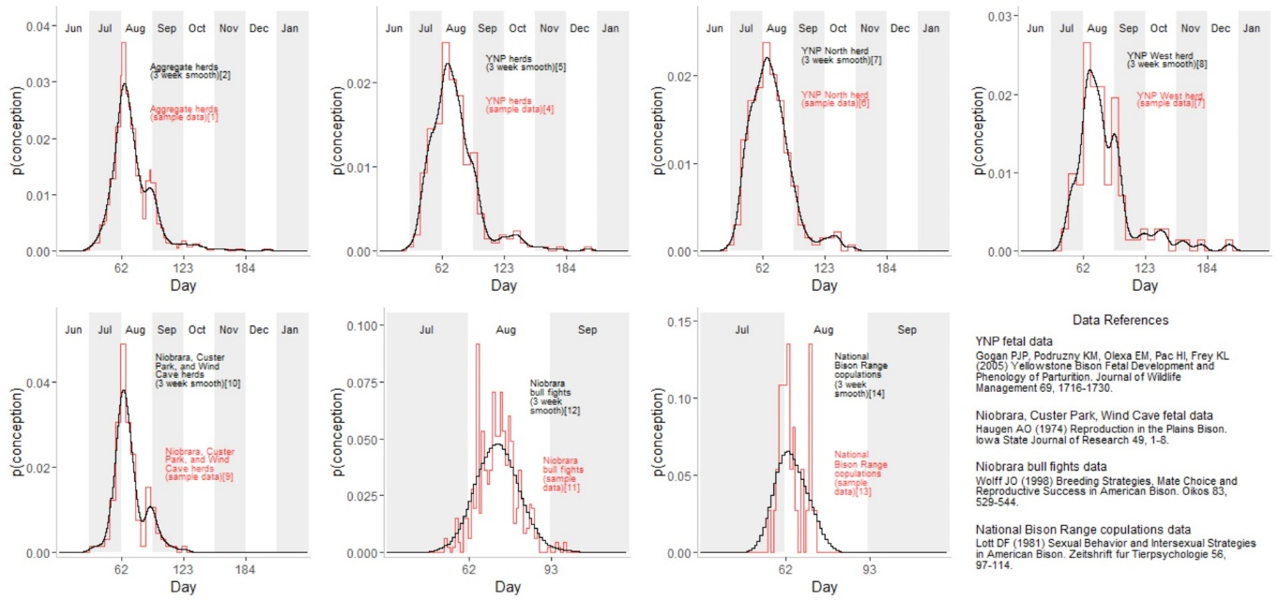

A plotting window displaying the conception distributions. It has been expanded so that the text and geometry are legible.

In the main paper, the analyses were completed with conception distribution 2, the aggregate herd distribution. Distributions 1-10 correspond to the fetal biometric estimations of conception dates. The final four distributions correspond to behavioral observations related to rutting activity. Odd indices indicate sample data and even indices indicating three-week smooths of the sample data.

Type the index number for your distribution of choice and hit [enter]. If you enter an invalid character, you will receive an error message and a prompt to re-enter an index.

The program will prompt you to adjust the growth curves to account for body size differences between modern *B .b. bison* and Pleistocene *B. b. antiquus*. Type y to make this adjustment or any other key to proceed with the standard growth curves for modern bison. If the adjustment is made, the script will output the file lengthratios.csv to the working directory. If lengthratios.csv already exists in the working directory, this step will be skipped.

Regardless of which growth curves are selected, the program will prompt you to display the growth curves. Type y and press [enter] to display these growth curves. You can press any other key to proceed without displaying the growth functions. If you display the growth curves, you are required to press another key to proceed.

The program will also prompt you to display plots of the length-minimum depth relationships for long bone diaphyses. To view these plots, type y and press [enter]. Otherwise, press any other key to proceed.

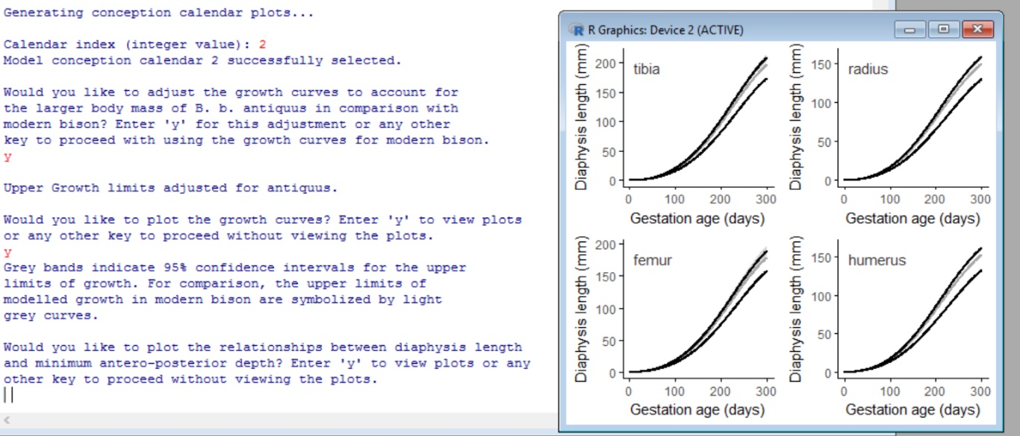

Growth curve plotting options displayed in the R console. Here, the user has opted to display the growth curves with the *antiquus* size adjustment. The plotting window displaying the growth curves overlaps the right side of the R console. The program is waiting for the user to press another key to proceed.

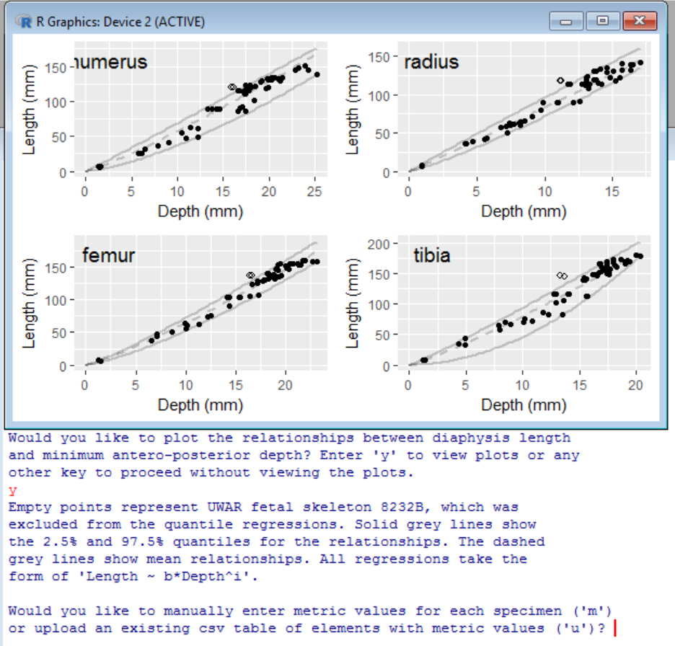

The user has opted to display the diaphysis length-depth relationships. The plotting window displaying the relationships is situated on the right side of the R console. The program is waiting for the user to select a mode of data entry.

1. ***Entering osteometric information***

The first data-entry prompt asks whether you would like to input values manually through the R console (m) or upload a csv table of metric values (u). If an invalid character is entered, the program will display an error message and prompt you to re-enter a method for data entry. Whichever method is chosen, values must correspond to minimum diaphyseal depth measurements in units of mm.

If you select manual entry (m), the program will first ask you to specify the number of specimens. Enter a positive integer *x* indicating the number of entries to be made. This will generate a prompt for each of *x* entries to be made, each of which includes the element type and its associated metric value. Valid element types include humerus, radius, femur, and tibia (do not capitalize or abbreviate element types). The script can read depth entries in whole mm (e.g., 95) or with sub-mm digits (e.g., 93.44).

If the csv table upload option is selected (u), text will be displayed that describes how the table should be formatted. The csv table requires two columns; the first column is for element types (humerus, radius, femur, and tibia) and the second column is for minimum depth metrics. The first row is read as a header (in the event that the first row contains data, these data will be excluded from analysis). Press any key to proceed from the text that describes table formatting. This will open a file browser to select the csv table. An error will be displayed if data in the csv file are incorrectly formatted. In this event, you will be prompted to upload a correctly formatted table. Cancelling out of the file navigation window will stop the script.

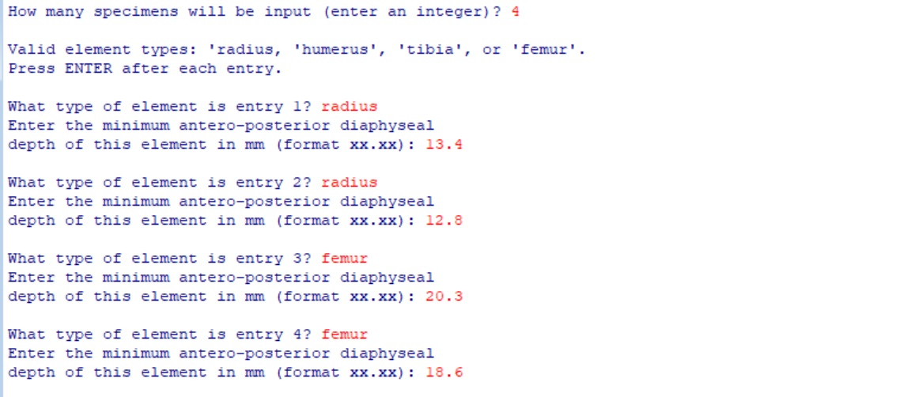

R console showing prompts for manual entry where the user has entered four specimens.

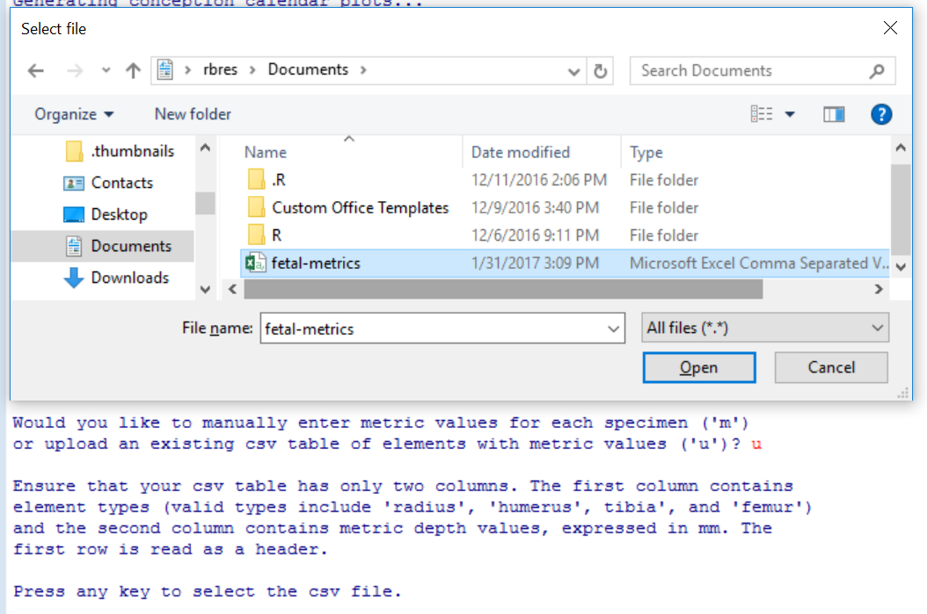

R console display overlaid by a file navigation window that has opened as a result of the user opting to upload a csv table of depth metrics.

During either upload method, the program may display an error indicating that a metric value is outside of the modelled range of fetal bison metrics. This error indicates that a metric value is too large or small to fit within the bounds of the growth models. If this error displays, ensure that each entry is indeed a fetal element as opposed to a calf element that falls outside of the range of modelled metrics. Also, ensure that there are no errors in the entered data. The program cannot proceed with metric values that fall outside of the range of modelled values.

The program will display SODEs after data entry is complete. In the R console, text blocks will list each element, its minimum diaphyseal depth, its estimated range of diaphysis lengths, its estimated range of gestation ages, and the dates that bound its SODE. The plotting window will show the probability distributions for each SODE. Plotted SODEs are color differentiated. The plot legend may not display SODE colors in the standard R interface, but colors will be visible in a saved PDF version of each plot. The legend will display SODE colors in the RStudio plotting window.

Next, you will be prompted to further analyze the SODEs. Type y and hit [enter] if you would like to perform any further analyses, such as assessing a seasonality hypothesis or constructing a single SODE from multiple specimens. The option to generate a SODE from multiple specimens is displayed only when there are multiple entries. Press any other key to exit the program.

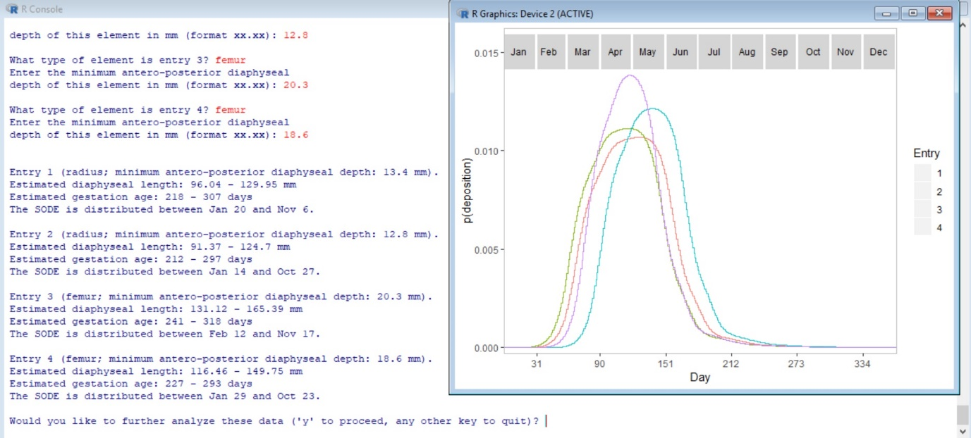

R console displaying SODE text for four specimens. The console is overlaid by a plot showing the SODE distributions.

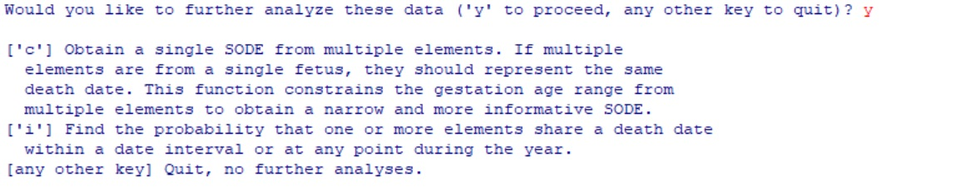

R console displaying options for a user that has indicated that they would like to perform further analyses (y).

1. ***Evaluating seasonality hypotheses***

To assess the probability that one or more specimens were deposited during a date interval, type i and hit [enter] at the prompt for further analyses. You will first be prompted to enter the indices for the SODEs that you would like to include. These are entered as comma-and-space-separated positive integers. Press [enter] after you have finished.

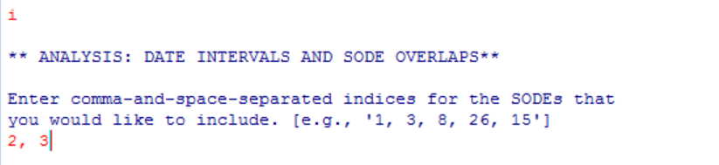

R console display showing a user that has entered two SODEs to be included in the analysis.

You will be prompted to indicate which dates define your seasonality hypothesis. A list of indexed dates is displayed for reference. Using these date indices, enter two comma-and-space-separated dates. If you do not have a specific hypothesized date range, but need to obtain the probability that two elements were deposited on the same date, type 1, 365 and press [enter].

The R console will first display the probability that the specified elements were deposited on the same date within the hypothesized interval (or, if no interval was specified, on the same date at any time in the year). Next, the script prints the probability that the specified elements were deposited within the date interval. This differs from the first probability in that the elements may have been deposited on different dates within the hypothesized interval. This second probability only prints if a hypothesized range was specified.

The plotting window will display color-differentiated SODEs for the selected elements with a grey rectangle showing the hypothesized date range. In the standard R interface, the plot legend may not display SODE colors. However, colors in the legend will be visible in an exported version of the figure. The legend should display SODE colors in the RStudio plotting window if the extent of the window is expanded sufficiently.

You will be presented the option to exit the program or to complete more analyses (e.g., evaluate other hypothesized intervals or obtain a SODE with a gestation age estimated from multiple elements).

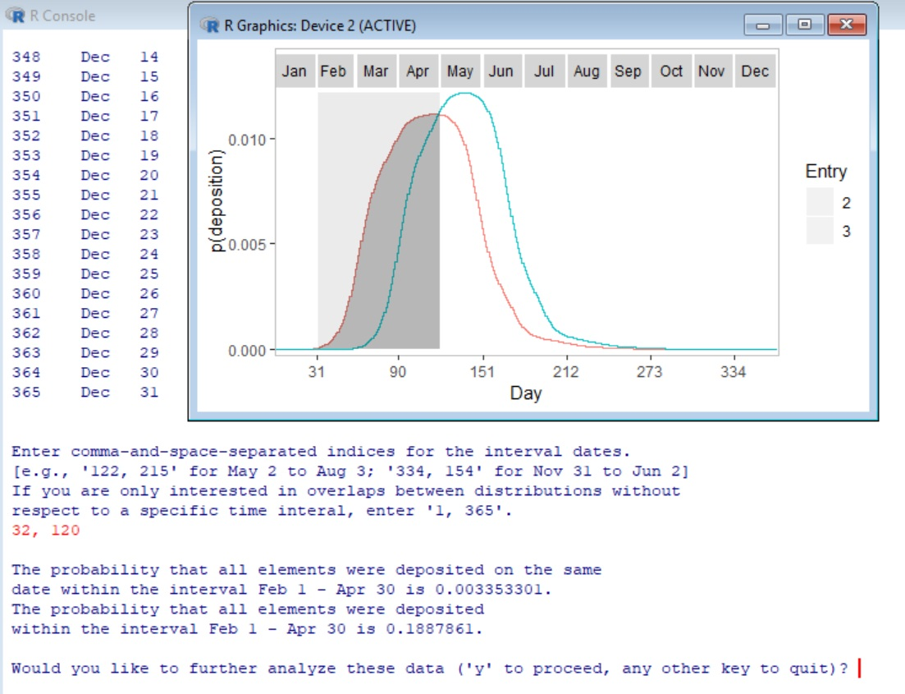

R console results overlaid with plotting window output for a date interval of February 1 - April 30 (indices 32, 120). The console displays the probability that both elements were deposited on the same date within this interval and the probability that both elements were deposited on any date within this interval.

1. ***Obtaining a SODE from multiple specimens***

To obtain a SODE from multiple specimens, type c and hit [enter] at the prompt for further analyses. Elements that qualify for this analysis include specimens that originate from the same fetus and therefore represent the same gestation age. This procedure finds the overlap in gestation ages between the specimens, which will generate a narrower age estimate and therefore a narrower SODE. You will first be prompted to specify entries for the specimens used to construct the SODE. Type these comma-and-space-separated numbers and press [enter]. The resulting SODE is stored as a new entry so that it can be used for other analyses, such as finding the probability that it falls within a hypothesized date interval. The console will display the dates that bound this SODE. The plotting window will display color-differentiated SODE distributions for the selected elements, and the multi-specimen SODE will be displayed with grey geometry. The plot legend may not display SODE colors in the standard R interface, although the colors will be visible in an exported version (this problem should not occur in RStudio).

The script will present you with the option for further analyses after displaying the new SODE.

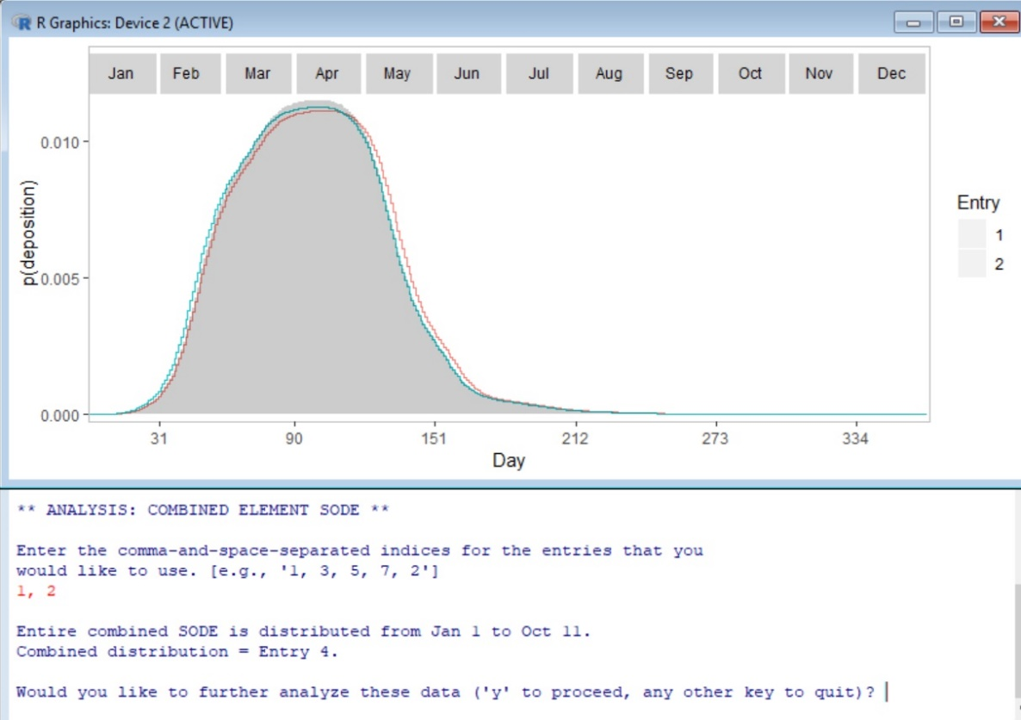

R console results overlaid with plotting window. The console displays the combined element SODE dates and its entry designation. The plotting window shows each color-differentiated SODE. The combined SODE is shown with a transparent grey fill.